# Homework 1 - Networking Utilities

Note: Zoom in on the outputs.

Ryan Taylor

## Task 1

* Take a screenshot of the output.

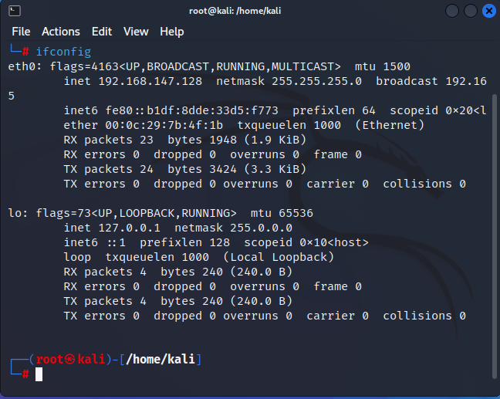

## Task 2

* Take a screenshot of the output.

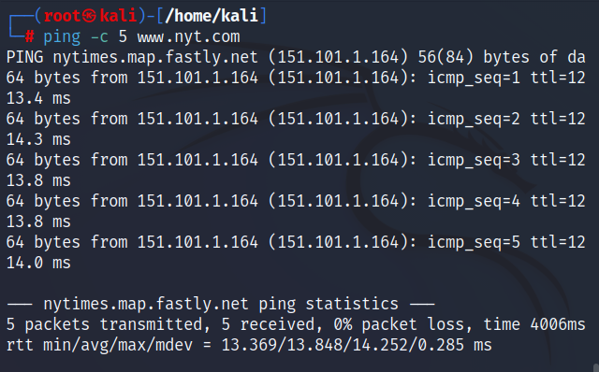

## Task 3

* Take a screenshot of the output.

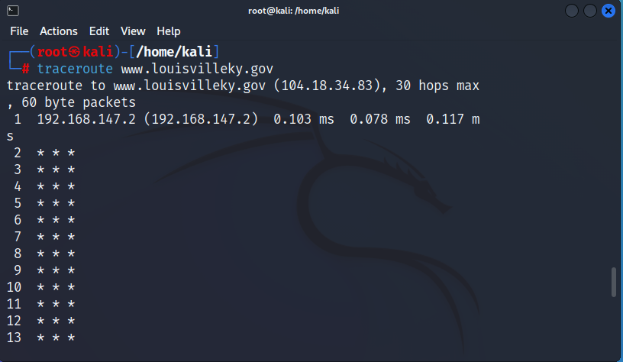

## Task 4

* Take a screenshot of the output.

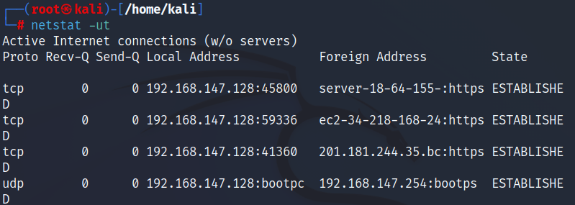

## Task 5

* Take a screenshot of the output.

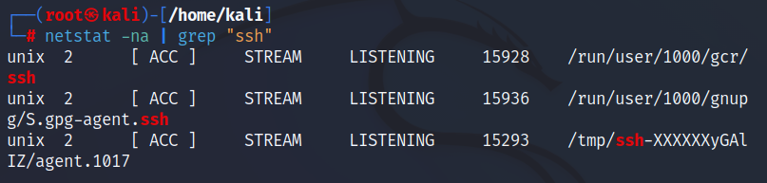

## Task 6

* Take a screenshot of the output.

